If a router cannot find a valid configuration file during the startup sequence, what will occur?
 | The startup sequence will reset.
 | The router will prompt the user for a response to enter setup mode.
 | The startup sequence will halt until a valid configuration file is acquired.
 | The router will generate a default configuration file based on the last valid configuration.
 | The router will monitor local traffic to determine routing protocol configuration requirements.

2
  Passwords can be used to restrict access to all or parts of the Cisco IOS. Select the modes and interfaces that can be protected with passwords. (Choose three.)
   | VTY interface
   | console interface
   | Ethernet interface
   | secret EXEC mode
   | privileged EXEC mode
   | router configuration mode
3
  What header address information does a router change in the information it receives from an attached Ethernet interface before information is transmitted out another interface?
  only the Layer 2 source address
  only the Layer 2 destination address
  only the Layer 3 source address
  only the Layer 3 destination address
  the Layer 2 source and destination address
  the Layer 3 source and destination address

4
  What three processes does a router execute when it receives a packet from one network that is destined for another network? (Choose three.)
  decapsulates the Layer 3 packet by stripping off the Layer 2 frame header
  uses the destination MAC Address in the IP Header to look up the next-hop address in the routing table
  leaves the Layer 2 frame header intact when decapsulating the Layer 3 packet
  uses the destination IP Address in the IP header to look up the next-hop address in the routing table
  encapsulates the Layer 3 packet into the new Layer 2 frame and forwards it out the exit interface
  encapsulates the Layer 3 packet into a special Layer 1 frame and forwards it to the exit interface
5
  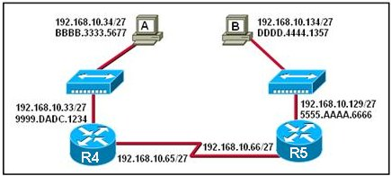
  Refer to the exhibit. Host A pings host B. When R4 accepts the ping into the Ethernet interface, what two pieces of header information are included? (Choose two.)
  source IP address: 192.168.10.129
  source IP address: BBBB.3333.5677
  source MAC address: 5555.AAAA.6666
  destination IP address: 192.168.10.33
  destination IP address: 192.168.10.134
  destination MAC address: 9999.DADC.1234

6
  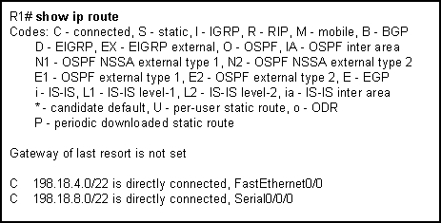
  Refer to the exhibit. What can be concluded from the routing table output in the exhibit? (Choose two.)
  This router only has two interfaces.
  The router interfaces are not operational yet.
  This router is configured to forward packets to remote networks.
  The FastEthernet0/0 and Serial0/0/0 interfaces of this router were configured with an IP address and the no shutdown command.
  An IP packet received by this router with a destination address of 198.18.9.1 will be forwarded out of the Serial0/0/0 interface.
7
  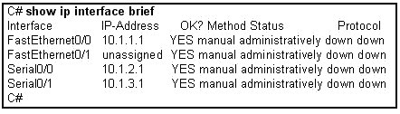
  Refer to the exhibit. The network administrator has configured the router with the interface IP addresses shown for the directly connected networks. Pings from the router to hosts on the connected networks or pings between router interfaces are not working. What is the most likely problem?
  The destination networks do not exist.
  The IP addresses on the router interfaces must be configured as network addresses and not host addresses.
  The interfaces must be enabled with the no shutdown command.
  Each interface must be configured with the clock rate command.

8
  From what location can a router load the Cisco IOS during the boot process? (Choose two.)
  RAM
  TFTP server
  NVRAM
  setup routine
  Flash memory
  terminal
9
  What is the default sequence for loading the configuration file?
  NVRAM, FLASH, ROM
  FLASH, TFTP,CONSOLE
  NVRAM, TFTP, CONSOLE
  FLASH, TFTP, ROM

10
  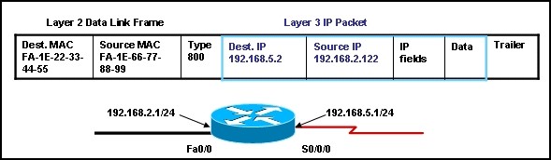
  Refer to the exhibit. The frame shown in the exhibit was received by the router. The router interfaces are operational. How will the router process this frame? (Choose two.)
  The router will change the source and destination IP address in the packet before forwarding the frame.
  The router will change the frame type to one supported by the WAN link before forwarding the frame.
  The router will use the destination MAC address to determine which interface to forward the packet.
  The router will look up the MAC address of the S0/0/0 interface in the ARP table and add it to the frame before forwarding.
  The frame was received on the Fa0/0 interface of the router and will be switched to the S0/0/0 interface.
  The frame was received on the S0/0/0 interface of the router and will be switched to the Fa0/0 interface.
11
  Which of the following is the correct flow of routines for a router startup?
  load bootstrap, load IOS, apply configuration
  load bootstrap, apply configuration, load IOS
  load IOS, load bootstrap, apply configuration, check hardware
  check hardware, apply configuration, load bootstrap, load IOS

12
  The network administrator needs to connect two routers directly via their FastEthernet ports. What cable should the network administrator use?
  straight-through
  rollover
  cross-over
  serial
13
  What information about the router and its startup process can be gathered from the output of the show version command? (Choose three.)
  the last restart method
  the command buffer contents
  the amount of NVRAM and FLASH used
  the configuration register settings
  the location from where the IOS loaded

14
  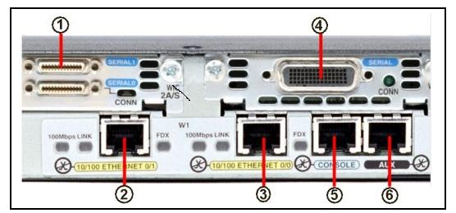
  Which interfaces in the exhibit could be used for a leased line WAN connection? (Choose two.)
  1
  2
  3
  4
  5
  6
15
  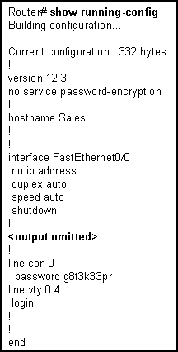
  Refer to the exhibit. What can be concluded from the output of the running-configuration of a router?
  The passwords are encrypted.
  The current configuration was saved to NVRAM.
  The configuration that is shown will be the one used on the next reboot.
  The commands that are displayed determine the current operation of the router.

16
  Which two statements describe characteristics of load balancing? (Choose two.)
  Load balancing occurs when a router sends the same packet to different destination networks.
  Load balancing occurs when the same number of packets are sent over static and dynamic routes.
  Load balancing allows a router to forward packets over multiple paths to the same destination network.
  Unequal cost load balancing is supported by EIGRP.
  If multiple paths with different metrics to a destinations exist, the router cannot support load balancing.

17
  What is the outcome of entering these commands?
  R1(config)# line vty 0 4
  R1(config-line)# password check123
  R1(config-line)# login
  ensures that a password is entered before entering user EXEC mode
  sets the password to be used for connecting to this router via Telnet
  requires check123 to be entered before the configuration can be saved
  creates a local user account for logging in to a router or switch
18
  Which are functions of a router? (Choose three.)
  packet switching
  extension of network segments
  segmentation of broadcast domains
  selection of best path based on logical addressing
  selection of best path based on physical addressing

19
  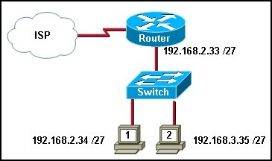
  Refer to the exhibit. After host 2 is connected to the switch on the LAN, host 2 is unable to communicate with host 1. What is the cause of this problem?
  The subnet mask of host 2 is incorrect.
  Host 1 and host 2 are on different networks.
  The switch needs an IP address that is not configured.
  The router LAN interface and host 1 are on different networks.
  The IP address of host 1 is on a different network than is the LAN interface of the router.
20
  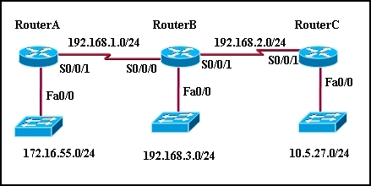
  Refer to the exhibit. All routers have a route in its routing table to each network that is shown in the exhibit. Default routes have not been issued on these routers. What can be concluded about how packets are forwarded in this network? (Choose two.)
  If RouterC receives a packet that is destined for 10.5.1.1, it will be forwarded out interface Fa0/0.
  If RouterA receives a packet that is destined for 192.168.3.146, it will be forwarded out interface S0/0/1.
  If RouterB receives a packet that is destined for 10.5.27.15, it will be forwarded out interface S0/0/1.
  If RouterB receives a packet that is destined for 172.20.255.1, it will be forwarded out interface S0/0/0.
  If RouterC receives a packet that is destined for 192.16.5.101, it will be forwarded out interface S0/0/1.

21
  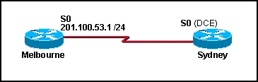
  The serial connection shown in the graphic needs to be configured. Which configuration commands must be made on the Sydney router to establish connectivity with the Melbourne site? (Choose three.)
  Sydney(config-if)# ip address 201.100.53.2 255.255.255.0
  Sydney(config-if)# no shutdown
  Sydney(config-if)# ip address 201.100.53.1 255.255.255.224
  Sydney(config-if)# clock rate 56000
  Sydney(config-if)# ip host Melbourne 201.100.53.2
22
  Which two statements correctly describe the components of a router? (Choose two.)
  RAM permanently stores the configuration file used during the boot sequence.
  ROM contains diagnostics executed on hardware modules.
  NVRAM stores a backup copy of the IOS used during the boot sequence.
  Flash memory does not lose its contents during a reboot.
  ROM contains the most current and most complete version of the IOS.
  Flash contains boot system commands to identify the location of the IOS.

23
  A network administrator has just entered new configurations into Router1. Which command should be executed to save configuration changes to NVRAM?
  Router1# copy running-config flash
  Router1(config)# copy running-config flash
  Router1# copy running-config startup-config
  Router1(config)# copy running-config startup-config
  Router1# copy startup-config running-config
  Router1(config)# copy startup-config running-config

